Results and discussion
5. Testing
5.1 Introduction
This section will start by presenting and describing the quantitative data that was collected from this study as highlighted in section 4.6.1. Essentially, this part will consist of the training graphs together with the evaluation of their results and their significance.
It will then continue by outlining the tests that were performed for both approaches that were highlighted in the study overview (4.3). The tests will be presented in the form of test cases. Following that, it will expand on the results produced by the test cases which were highlighted in section 4.6.2.

5.2 Training results

Generalised reinforcement learning agents

For this approach, the agents were left to train for approximately 11.36 million steps to ensure they cover as much environment variations as possible.
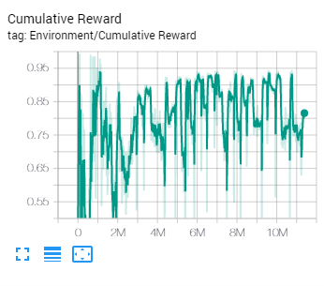
Figure 1: Cumulative reward (generalised reinforcement learning agents)

It was observed that with this approach, as shown in Fig. 1, the cumulative reward would start to stabilise as soon as a small number is picked from the sampler, setting the floor to a small size as a result. In this training run, it started to stabilise after around 2 million steps. It was also observed that whenever the environment was reset, the cumulative reward would suddenly decline and rise again shortly after. This was because as the environment changes, the agents would need some time to adjust to the change; once they do, their performance returns to normal. Lastly, it was observed that the bigger the floor size, the lower the cumulative reward. Given that the agent received a small penalty for every action it performed, this is normal. As the floor grows, an agent must move for a longer distance, and hence perform more actions, until it reaches its target. The maximum attainable cumulative reward was 1; for the most part, the cumulative reward stayed between 0.75 and 0.95, which met expectations.

Curriculum learning
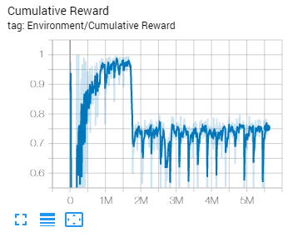
Figure 2: Cumulative reward (curriculum learning)
For this approach, the agents were left to train for approximately 5.6 million steps as shown in Fig. 2. Throughout the first 1 million steps, the cumulative reward rose steadily as the agent progressed through the lessons until it reached the last one. The sudden decline at around 1.8 million steps is a result of the penalty per action triggering 2000 seconds into the training (note: the methodology has been updated to reflect this). The cumulative reward fluctuated throughout the rest of the training. Like in the first approach. The fluctuations are a result of the periodic changes in the environment. For the most part, the cumulative reward stayed between 0.6 and 0.75. This was slightly below expectations; it was expected that it would be comparable to that in the first approach, if not higher (refer to Fig. 3). In this approach, as highlighted in 4.4.6, the size of the environment remained the same from the 500,000th step onwards. For this reason, it was thought that the agent would find it easier to adjust to the large environment.
Since there was no increase in the reward after approximately 3.5 million steps, it was felt that there would be no point in leaving the agents to train for longer, hence the difference in training steps between approaches.

These results cannot be compared to results from other studies due to the difference in approaches. In the study by Vadim, Tatyana and Oksana (2018), for example, the agent was able to achieve a cumulative reward of 100 after 50,000 steps, but the methods with which it was trained and given rewards differed from the ones used in this study.

Training differences:
In their study, the agent was trained via imitation learning and reinforcement learning simultaneously. With this approach, the agent has shown to require significantly less training time compared to when reinforcement learning was used by itself. There are two ways with which imitation learning can be used in conjunction with reinforcement learning in ML-Agents; Behavioural Cloning (BC) and Generative Adversarial Imitation Learning (GAIL). Although it is not explicitly stated, it is evident that Vadim, Tatyana and Oksana (2018) used BC for their approach since ML-Agents did not offer the possibility to train agents via GAIL at the time. As stated in the ML-Agents documentation, BC is ideal when there exist demonstrations for nearly all the states that can be experienced by the agent. This is because it cannot generalise past the examples shown in the demonstrations, thus being unsuitable for this study. The ML-Agents documentation states that GAIL, on the other hand, works well when there is a limited number of demonstrations. For this reason, during the prototype development stage, an attempt was made to train the agents via Generative Adversarial Imitation Learning (GAIL). Several demonstrations were recorded in an environment consisting of a 20 by 20 plane and several obstacles. The agents were then trained with these demonstrations, but no difference was observed in the learning rate.

Reward differences:
For their approach, Vadim, Tatyana and Oksana (2018) rewarded their agent for multiple tasks per step. In this study, the agent’s reward was set to 1, rather than added. As stated in the ML-Agents documentation, when there are multiple additions to the reward for a single agent decision, the rewards are summed together to evaluate how good the previous decision was. It is for this reason that the agent in their study was able to achieve a cumulative reward of 100. When the reward is set, all previous rewards are overridden, so the maximum the cumulative reward can be is the number it is set to. In this study, the agent had its reward set to 1 whenever it reached its target because that was the only task it was rewarded for.

The approach used in the study by Youssef et al. (2019) is comparable to that used by Vadim, Tatyana and Oksana (2018).

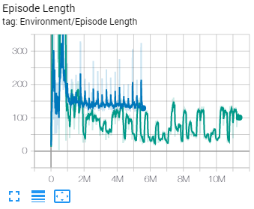
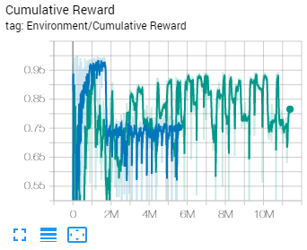
Figure 4: Episode length for both approaches
Figure 3: Cumulative reward for both approaches

In Figures 3 – 7, the green graph is the first approach (generalised reinforcement learning agents); blue is the second approach (curriculum learning).

The training episode was set to end when the agent falls off the level or reaches its target. From Fig. 4, it can be observed that initially, the episode length was high for both approaches. This is normal, as during that period, the agents were still familiarising themselves with the environment. However, as the training stabilised, the episode length for the first approach stayed much lower than that in the second one. The difference in episode length shown in Fig. 4 indicates that in the first approach, the agent took less time to perform its task than in the second one.

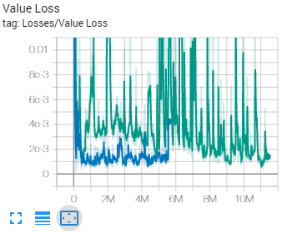
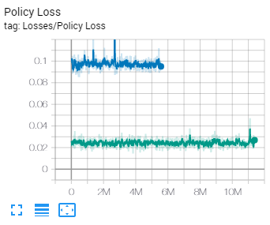
Figure 6: Value loss for both approaches
Figure 5: Policy loss for both approaches

The ML-Agents documentation states that the magnitude of the policy loss should decrease during a successful training session. As shown in Fig. 5, the policy loss stayed the same for both approaches throughout the training but was higher when the agents were trained via curriculum learning.
The value loss should increase while the agent is learning and then decrease once the reward stabilises. In the first approach, despite having several fluctuations due to environment changes, it has decreased once the training stabilised, as shown in Fig. 6. In the second approach, it started high but quickly decreased. The disparity in the magnitude of the fluctuations between approaches could most likely be due to the differences with which the environments were changed

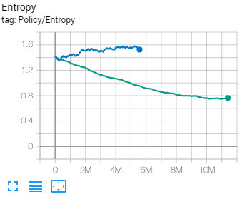

Figure 7: Entropy for both approaches

As stated in the ML-Agents documentation, the entropy refers to the randomness of the model decisions; it should slowly decrease during a successful training process. From Fig. 7, it can be observed that for the second approach, the entropy rose rather than decreased.

From these results, it can be deducted that the training has been more stable in the first approach.

Test cases:

All tests were performed on a plane of 20 by 20 or smaller.

Test case no. | 01
Approach | Generalised reinforcement learning agents
Description | A single agent moved from one point to another.
Expected result | If the target is within training coordinates, the agent takes the shortest path to it while avoiding any obstacles in the way.
Actual result | The agent would behave erratically if its target is far away from it; it would move in the opposite direction, fall off the map, or take an unnecessarily long path to the target. This has shown to occur primarily from the target being placed very far away from the agent, such as from bottom left to top right on a 20 by 20 plane, for example, but has shown to be hit-or-miss, meaning that it has happened as well with smaller maps.  Otherwise, the agent moves normally while managing to take the shortest path and avoid obstacles. It was observed that sometimes, the agent would collide with an obstacle and then correct its behaviour shortly after, rather than avoid it altogether. It was also observed that the agent would occasionally behave erratically when there is a cluster of objects between it and its target; it would act as if there is a wall that is preventing it from moving further.

Test case no. | 06
Approach | Curriculum learning
Description | A single agent moved from one point to another.
Expected result | If the target is within training coordinates, the agent takes the shortest path to it while avoiding any obstacles in the way.
Actual result | Unlike in test case no. 1, the agent’s performance did not seem to be impacted if its target is very far away from it.  In some cases, an agent would miss its target and then correct its behaviour shortly after.

During the development stage, testing was initially performed on a plane whose size was set so that it could only grow to a maximum of 10 by 10 during training, as opposed to 20 by 20. In that case, the agents have shown to perform outstandingly, but a size of 10 by 10 was considered too low to be viable for an RTS game, so it was doubled to allow for at least two players to be able to play comfortably in a hypothetical scenario. As a result, a decrease in training stability was observed. It is believed that this can be attributed to the fact that the agents receive a small penalty per action but are only given a reward upon reaching their targets. As previously mentioned in the training results section, a larger map increases the likelihood that an agent would have to travel over longer distances to reach its targets. This means that it would have to earn a substantial number of small penalties until it is given a reward.

It is believed that increasing the maximum map size has directly contributed to the erratic behaviour that was observed in test case no. 1, as this behaviour was not recorded when the agents were trained in a map that could expand to a maximum of 10 by 10. Although the agents should have been able to perform well in a map of up to 20 by 20 in size, their performance seems to have degraded even in maps that are smaller than 20 by 20. Strangely, this behaviour did not occur when the agents were trained via curriculum learning. The exact reason for this could not be pinpointed. It is believed that it is because the agents spent a longer time training in the 20 by 20 map, as unlike in the generalized learning approach, the size of their map did not change periodically throughout the entirety of the training.

Test case no. | 02
Approach | Generalised reinforcement learning agents
Description | A group of 100 agents moved from one point to another at once.
Expected result | If the targets are within training coordinates, the agents take the shortest path to them while avoiding any obstacles in the way.
Actual result | Comparable to that in test case no. 1.  Differences: It was observed that although most of the agents were able to arrive to their target and stop moving, the ones that did not would get surrounded by the other agents and ultimately either fail to stop at their target, or take considerable time to do so. They would stay within the circle of targets but keep moving back and forth or left and right as if they are stuck.

Test case no. | 07
Approach | Curriculum learning
Description | A group of 100 agents moved from one point to another at once.
Expected result | If the targets are within training coordinates, the agents take the shortest path to them while avoiding any obstacles in their way.
Actual result | Most of the agents would never properly reach their targets. Unlike in test case no. 2, they would gather around the targets as shown in Fig. 8 and keep moving in circles indefinitely. Strangely, this occurred primarily when the agents were sent near the edges of the plane; its severity was much less when the agents were sent to the centre of the map, for example. It was also noted that the agents would occasionally take a longer path for no apparent reason. Example: If the agents are sent from the top right corner of the plane to the bottom left, they first move downwards and then left a while after, rather than move diagonally in the first place.  The result from test case no. 6 applies here as well.  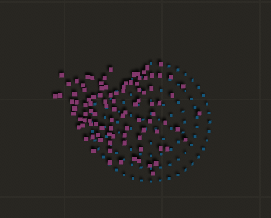  Figure 8: The agents fail to reach their targets in large groups.

In both approaches, the agents did not perform as expected. As mentioned, in test case no. 2, a high majority of the agents were successful in reaching their targets in groups. However, there were a few exceptions. As most of the agents reach their target, they gather around the few which do not, essentially blocking them in. The reason for this is believed to be that since during training, the agents had been penalised for colliding with each other, they refrain from pushing past the other agents to reach their targets during inference.
The reason for the agents’ lack of ability to stop at their targets observed in test case no. 7 is unknown.

Test case no. | 03
Approach | Generalised reinforcement learning agents
Description | Two groups of 100 agents moved at once in a way that their paths intersect.
Expected result | The agents avoid each other and continue moving.
Actual result | For the most part, the agents showed a good ability to avoid each other while moving in groups, albeit some pushing occurred with no obstacles. The addition of obstacles worsened this, but the agents were able to separate nonetheless.

Test case no. | 08
Approach | Curriculum learning
Description | Two groups of 100 agents moved at once in a way that their paths intersect.
Expected result | The agents avoid each other and continue moving.
Actual result | Comparable to test case no. 3.

Test case no. | 04
Approach | Generalised reinforcement learning agents
Description | Obstacles placed in front of an agent while it is moving.
Expected result | The agent acknowledges the obstacles, avoids them and continues moving.
Actual result | Generally, the agent was able to immediately adjust itself to the obstacle and avoid it altogether. In some cases, the agent would collide with an obstacle and then correct its behaviour shortly after.

Test case no. | 09
Approach | Curriculum learning
Description | Obstacles placed in front of an agent while it is moving.
Expected result | The agent avoids them and continues moving.
Actual result | Comparable to test case no. 4.

Test case no. | 05
Approach | Generalised reinforcement learning
Description | Obstacles placed in front of a group of 100 agents while they are moving at once.
Expected result | The agents acknowledge the obstacles, avoid them and continue moving.
Actual result | Comparable to test case no. 4.  The agents distributed themselves as shown in Fig. 9, rather than choosing the same path.  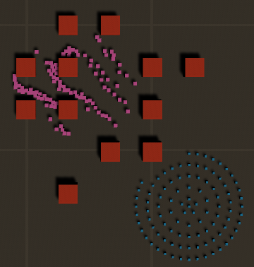  Figure 9: The agents distribute themselves accordingly when faced by obstacles.

Test case no. | 10
Approach | Curriculum learning
Description | Obstacles placed in front of a group of 100 agents while they are moving at once.
Expected result | The agents avoid them and continue moving.
Actual result | Comparable to test case no. 4.

It was observed that in some cases, the agents would appear to be stuck trying to reach a target that does not belong to them. This has shown to happen intermittently, and although it was observed in agents from both approaches, it occurred with slightly higher frequency in agents that were trained via curriculum learning. It is believed that this could have had to do with the agents’ ray perception sensors. Ray perception sensors detect objects via tags and since for this study, the targets were assigned to the list of detectable objects, it is believed that the agent might have confused its target with others that do not belong to it.

The above test cases show that in both approaches, the agents’ behaviour lacked in consistency. It was observed that the agents from the first approach were unable to adapt to their environment due to the behaviour they have shown when moved to positions that are far away from them. This behaviour was not observed in agents from the second approach. Moreover, at times, the agents from both approaches were unable to pass through clusters of obstacles despite there being enough space for them to do so.
A difference in movement between approaches was also observed. The agents from the first approach have shown that their movement is much more refined whereas those from the second approach tended to move roughly. In an RTS game, the units would ideally move smoothly, as the zig zags in movement lengthens the path.

From this, it can be deducted that the agents from the second approach showed a better ability to adapt to their environment than the agents from the first one.

1-on-1 interviews

As highlighted in section 4.6.2, 1-on-1 interviews were conducted with three participants who are familiar with the RTS genre. For the interviews, the participants were sent the two prototypes; one per approach. They were asked several questions while they experimented with the prototypes. In the beginning of each interview, the participant was instructed as to how to interact with the prototype and given a brief explanation of the research objectives and approaches.

Participant 1:
Approach 1 (generalised reinforcement learning agents):
Participant 1 noted that the agents would not stop at their targets per se; they stop earlier. As highlighted in section 4.4.2, this was by design; having the agents stop at a short distance away from their targets helped create more space for when they must stop at their targets in groups. In fact, during the prototype development stage, the behaviour in test case no. 2 would have been much worse if this had not been implemented. It was stated by the participant that they would have preferred if the agents stopped at the exact position of their target. The participant also stated that they were mildly bothered by the fact that some of the agents would never stop moving when they are moved in groups. When the participant was asked whether they thought the prototype was production ready, they stated that they do not feel it is because the agents are not consistent in terms of performance. The participant then elaborated by giving the following reasons:
- They cannot be moved in long distances due to the behaviour observed in test case no. 1;
- Some of the agents never stop moving completely when they reach their targets in groups;
- Although they were satisfied with how the agents performed when moved through obstacles or other agents, they were mildly bothered by the pushing that occurred between agents;
- Some pushing occurs when groups of agents are moved in such a way that their paths intersect;
- Rather than acknowledge a wall immediately, they sometimes bump into it first, or worse, briefly “hug” it.

Approach 2 (curriculum learning):
The participant was asked if they had noted any differences between the previous approach and this one. It was stated by the participant that they preferred the other approach over this one. They described the agents in the second approach as unresponsive and stated that although the agents were not affected by long distances, their movement was much rougher, especially in large groups.

Participant 2:

All figures in this section are screencaps from the interview recordings.

For the first approach, the following observations have been made by the participants as highlighted in the appendix:
- The agents behave erratically when their targets are placed very far away from them, but it has been observed that this does not always happen. An example of this can be seen in Fig. 10. The agents were sent the position of the cursor; they were able to move to it without problems.
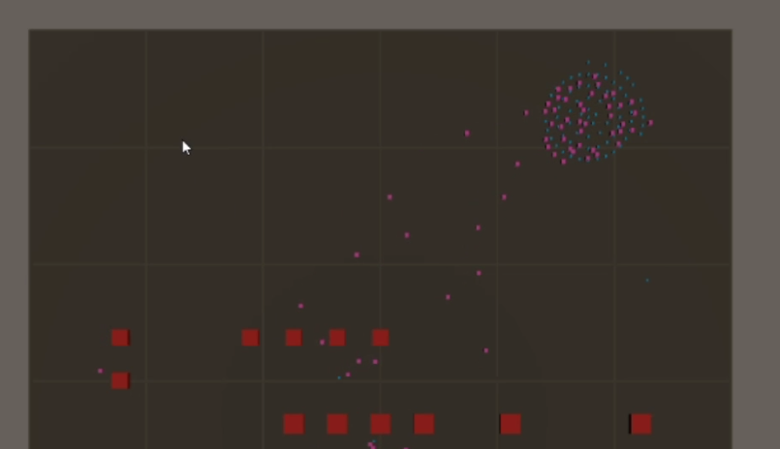
Figure 10: Sending the agents far from their current position

- Single unit movement was okay for the most part.

- When the agents are moved in large groups, some of the agents were surrounded by those that had managed to stop at their targets as shown in Fig. 11. As such, they either kept moving in circles or pushed past stationary agents to reach their targets.

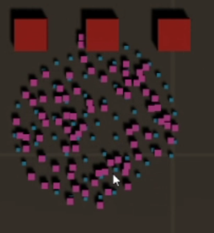
Figure 11: The remaining agents getting surrounded by the others

- When the agents are faced with obstacles, they sometimes bump into them and then correct their behaviour immediately after. However, they were generally good at avoiding obstacles.

- The agents have shown to be good at avoiding each other, albeit some pushing occurred.

- The agents moved smoothly; their movement was free from abrupt stops or zigzags.

- When moved in groups, some of the agents freeze; the other move normally.

- The agents do not always take the optimum path when sent to a location. An example can be seen in Fig. 12, in which although the agents were sent to the right, they chose to first move down and then to their paths, rather than going right altogether. In Fig. 12, the obstacles could also have negatively impacted the agents.

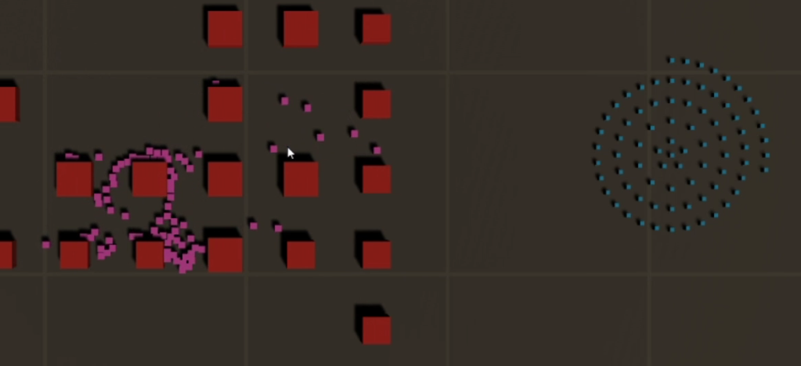
Figure 12: The agents taking a longer path than necessary

- In some cases, the agents take long to pass through clusters of obstacles as if there is a wall as shown in the bottom right of Fig. 13.
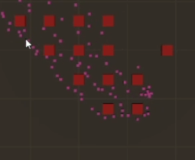
Figure 13: Some of the agents reacting poorly to obstacles
- This approach is not production ready; several improvements must be made to it before it can be used in a finished game.

For the second approach, the following observations have been made by the participants as highlighted in the appendix:
- When they are sent to targets that are far away from them, the agents do not exhibit the same behaviour as in the first approach. However, their ability to stop at their targets was worse as shown in Fig. 14; but this did not happen everywhere in the map. In Fig. 15, for example, the agents were sent near the centre of the map and were able to reach their targets.

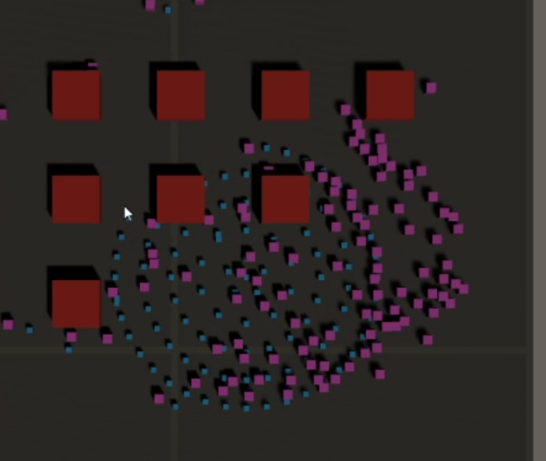
Figure 14: The agents attempting to reach their targets

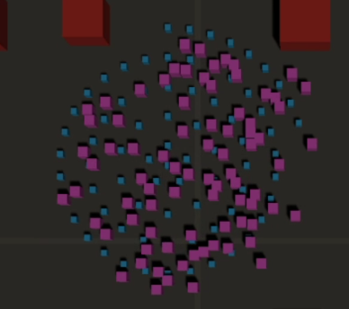
Figure 15: The agents reach their targets without much problems

- Single unit movement was also good for the most part.

- The agents in this approach behaved similarly to those in the first approach when faced with obstacles or other agents.

- Group movement was not bad; the agents in this approach scattered more as they moved.

- The agents’ movement was less smooth; they have shown to zigzag when moving.

- Like in the first approach, the agents do not always take the shortest path to their targets.

- The agents frequently get stuck trying to “reach” targets that do not belong to them.

- The agents’ performance seems to have been the worst near the edges of the map.

- The agents react poorly to clusters of obstacles; this was observed as well in agents from the first approach.

The observations that have been made by the participants are comparable to those from the test cases. It has been observed by the participants that both approaches lacked in consistency; their performance, for example, would be acceptable in some parts of the map but declines in others. Two of the participants have stated that they preferred the first approach over the second one. The participants have observed the following significant differences between approaches:
- Movement: The agents from the first approach have shown that their movement is refined whereas the others have shown to move roughly, their movement consisted of sudden zigzags.
- Group movement: In the second approach, group movement has not been bad per se, but the agents have shown to be unable to arrive to their targets in groups in most cases.
- Behaviour in large maps: In the second approach, the map size did not seem to have severely affected the agents’ ability to move to their targets when they are sent to a position that is far away from them.
- Behaviour near the edges of the map: The agents from the second approach have shown a tendency to behave erratically when sent to a target that is close to the edge of map.
- Reaction to targets: In the second approach, the agents would frequently attempt to reach targets that do not belong to them.

Appendix:

Interview with participant 1
Interviewer: For my research, I have developed two prototypes to study the use of machine learning for pathfinding in RTS games. Generally, games make use of deterministic algorithms for pathfinding, such as the A* search algorithm, for example. For my study, I have trained the agents to move to a target via machine learning, rather than hardcoded them. I will go ahead and send you the prototype for the first approach, in which I have attempted to train the agents in a way that they generalise to tweaks in the environment. This involves having the environment change periodically during training, so that the agent can get used to the variations.
Interviewee: Ah okay, I see. I am going to start sharing my screen.
Interviewer: Thank you.
Interviewee: This looks interesting.
Interviewer: You can zoom in or out via the scroll wheel and move the camera via the WASD keys. To spawn an obstacle, you move the cursor to where you want to spawn one on the map and then press the 1 or 2 number keys. To spawn a unit, you simply click on an obstacle. You can select multiple units by pressing and holding down the left mouse button; to move them, simply right click anywhere on the map. If you want to clear the map from agents and obstacles, click the clear button at the bottom left corner of the screen. You can also resize the map by pressing the left or right square brackets, but I suggest that you do not do it for now.
At this point, the participant experiments with the controls.
Interviewee: So, this is like playing Planetary [Planetary Annihilation: TITANS], right?
Interviewer: Yes, it is.
Interviewee: Okay.
Interviewer: I am noticing that the units do not stop at their targets.
Interviewee: Yes, that is by design; when they stop earlier, they create more space for the last ones to manoeuvre to their targets.
Interviewee: Hmm, okay, I understand how it works. Also, when I move large groups of units, some of them never stop moving upon reaching their targets.
Interviewer: Yes, that is a limitation, unfortunately.
Interviewee: There was a unit which, although it seemed like it managed to arrive to its target, it kept pushing the others.
Interviewer: Yes, that is because it had never really reached its target, so it kept pushing past the others to reach it.
Interviewee: I see.
Interviewer: Can you try moving a single unit to different points and share your thoughts on its performance?
Interviewee: Sure… single unit movement seems to be great, but they [the units] behave abnormally when their targets are placed far away from them.
Interviewer: Yes, that was observed during testing. The exact cause of the problem is unknown.
Interviewee: Some of them begin moving to their targets but the others either freeze or just move in the opposite direction. Where the units exposed to the whole map during training?
Interviewer: Can you elaborate, please?
Interviewee: Were they able to move in all parts of the map during training?
Interviewer: Oh, I understand now. Yes, the targets were programmed to spawn at random places in the map. Considering they trained for approximately 2 hours, I’d say they should have covered most of the map in that time, if not all of it.
Interviewee: Hmm, their behaviour is truly strange.
Interviewer: If you want to see how they behave in areas they were not trained in, enlarge the map and try sending them to an “out-of-bounds” position.
Interviewee: It is as if there is an invisible wall that stops them from going further. So, the maximum size is this [pointing to training boundaries].
Interviewer: Exactly, smaller is okay though. Can you reduce the map size, clear the level, and try spawning and moving a large group of units while spawning obstacles as they move?
Interviewee: Sure… some of them [the units] must arrive very close to an obstacle before avoiding it; they do not acknowledge it immediately, although I must say that overall, they are very good at adapting to them.
Interviewer: Now, leave those [the previous group of units] there, try spawning another large group of units and then move both so that they must move into each other to reach their targets.
Interviewee: They are not bad at all, but some units are pushing each other.
Interviewer: How do you feel about their performance in general?
Interviewee: Personally, I think they’re quite good. Their ability to avoid obstacles, for example, was impressive. Honestly, I’ve found it mildly bothering that the units stop earlier when they reach their target.
Interviewer: That’s understandable.
Interviewee: I also think I’d find it frustrating to have the units keep moving when they cannot reach their targets [in groups], or to behave erratically when sent far away from their positions.
Interviewer: How do you feel about this being used in an actual RTS game?
Interviewee: I don’t think it’s good enough to be production ready. The problems would first need to be ironed out. Other than that, it’s nice.
Interviewer: Fair enough. I think that’s all for this approach; you can go ahead and close it. I will be sending you the second prototype.
Interviewee: Okay.
Interviewer: This will work the same way, but a different method was used to train the agents. During training, their map grew steadily as they performed better. When the map grew to max size, the obstacles in the environment were reset periodically to help them get used to different environment variations.
Interviewee: So, basically, the task becomes harder by growing as they progress, right?
Interviewer: Yes, exactly; if they are trained in a large environment from the start, they will never manage to improve. Can you please experiment with this and see if you can notice any differences in the way the units perform?
Interviewee: When I move the units, they are not reaching their target. They have accumulated at one side of the circle [of targets] and seem to be stuck.
Interviewer: Yes, I really don’t know why they do that.
Interviewee: Strangely, they seem to perform [group movement] better in certain parts of the map. Here [in the centre], for example, most of them seem to have settled. Should I try experimenting with obstacles as well?
Interviewer: Yes, of course!
Interviewee: I am going to try the same experiment as before [moving them in groups so that their paths intersect].
Interviewer: Okay.
Interviewee: There was not much pushing.
The interviewee experiments with group movement for a moment.
Interviewee: I’ve tried sending them to he left but they seem to be moving up.
Interview: This approach has shown to be hit-or-miss generally.
Interviewee: Yes, in fact, they’ve arrived here [to the left of the map] and most of them have stopped moving; they’re not gathering to the left side [of the circle] like before. I will try making the map smaller and move them to the same point [where they were not arriving to their targets].
Interviewer: Sure, go ahead.
Interviewee: They do the same thing. This agent here seems to be stuck in a target that doesn’t even belong to it.
Interviewer: Yes, that is something that has happened even during training. I have no idea why it’s happening. The agents from the other approach have done it as well, but it’s worse in this approach.
Interviewee: I can also notice that their movement is much more scattered than in the previous approach.
Interviewer: I think that’s all for this approach. Which one did you prefer?
Interviewee: I’ve preferred the other one more. The agents in the other approach seemed more responsive to me; their movement was smoother.
Interviewer: Fair enough. Thank you for participating!

Interview with participant 2
Interviewer: For my research, I have developed two prototypes to study the use of machine learning for pathfinding in RTS games. Generally, games make use of deterministic algorithms for pathfinding, such as the A* search algorithm, for example. For my study, I have trained the agents to move to a target via machine learning, rather than hardcoded them. I will go ahead and send you the prototype for the first approach, in which I have attempted to train the agents in a way that they generalise to tweaks in the environment. This involves having the environment change periodically during training, so that the agent can get used to the variations.
Interviewee: I’ve extracted the archive and opened the prototype… I am going to share my screen… ready when you are.
Interviewer: Thank you. I am going to explain the controls. You can zoom in or out via the scroll wheel and move the camera via the WASD keys. To spawn an obstacle, you move the cursor to where you want to spawn one on the map and then press the 1 or 2 number keys. To spawn a unit, you simply click on an obstacle. You can select multiple units by pressing and holding down the left mouse button; to move them, simply right click anywhere on the map. If you want to clear the map from agents and obstacles, click the clear button at the bottom left corner of the screen. You can also resize the map by pressing the left or right square brackets, but I suggest that you do not do it for now. Other than that, you can start experimenting with it as you like.
At this point, the participant experiments with the controls.
Interviewee: I imagine the agents won’t be able to reach their targets if I build on them [the targets], right?
Interviewer: No. Unfortunately, I have not implemented any form of target validation.
Interviewee: Ah okay, I see. From what I’m seeing, they [the agents] are handling it [group movement] very well; I am placing obstacles and they are avoiding them. They are also not hitting or pushing each other.
Interviewer: There is something you can do to determine their ability to move in large groups; try spawning two large groups of units and then send them to move against each other.
Interviewee: Oh okay, I am going to clear the map.
Interviewer: Sure, do whatever you like… do you notice that some of the agents fail to stop moving when they are near their targets?
Interviewee: Yes, could this be because they are in a heavily populated area?
Interviewer: It could be, but strangely, all the agents at the bottom left have stopped moving.
Interviewee: I am going to try sorting [moving them to the same position] them [the group of agents at the top right] again.
Interviewer: I am unsure of the exact reason for this, but I think it could be because during training, the agents might have spent more time moving in certain areas of the map than they’ve spent in others.
Interviewee: It’s not that serious to be honest.
At this point, the participant tries moving the two groups of agents from one corner to the opposite one, but they move to the opposite direction and fall off the map.
Interviewer: This is another problem that has been happening; I am unsure why, though.
Interviewee: No problem. I’ve worked with machine learning, so I understand this. I am going to clear the map, make it smaller, and try moving doing it [the test] again.

Interviewer: Sure, you can try.
At this point, the participant tries moving the agents; they do the same thing.
Interviewee: Hmm, I’ve worked with machine learning in the past, specifically computer vision and datasets; when you subject the system to things which were not present during training, similar problems [to this] tend to happen.
Interviewer: Strangely, these were trained in varying environments. I am also suspecting that it could be because the targets are very far away from the agents.
Interviewee: I see, I am going to split them and try moving them to another position… they’re fine now. Could this have been happening because they were in a tight area?
Interviewer: Hmm, but they were in a similar situation earlier.
Interviewee: The comment I would make is that when there are a lot of agents close to each other, their performance seems to suffer, but overall, I think that their pathfinding is decent.
Interviewer: Okay, I see.
Interviewee: I am going to try switching corners and moving them again… it’s not as bad this time. I mean, overall, their performance is good; they have managed to avoid each other. I am going to try filling the whole map with obstacles; I am not expecting them [the agents] to do well… actually, they are still able to move and avoid them [the obstacles]. That’s impressive.
Interviewer: Thank you. I think that’s all for this approach. You can go ahead and close it. I am going to send you the second prototype. This will work the same way, but a different method was used to train the agents. During training, their map grew steadily as they performed better. When the map grew to max size, the obstacles in the environment were reset periodically to help them get used to different environment variations.
Interviewee: Ah okay.
Interviewer: Try experimenting with it and see if you notice any differences.
The participant sends multiple groups of agents to different locations on the map. One of the groups moves near the edges and some of its agents end up falling off the map.
Interviewer: Some of them have fallen off the map.
Interviewee: Hmm, yes. I am going try selecting all the units and moving them as one large group… group movement is noticeably worse in this approach, although they are avoiding obstacles just as well.
Interviewer: You can try moving them against each other.
Interviewee: Most of the agents keep moving.
Interviewer: I agree; in an actual game, they cannot perform like this. During testing, I’ve played around with different map sizes for training and it seems that increasing the maximum map size has worsened their performance in general.
Interviewee: Yes, but you’re aiming towards peak performance. I feel that just because their performance isn’t perfect, it does not mean they’re bad per se. They need refinement in the training, or better implementation, but the concept is there.
Interviewer: Thanks for your insight.
Interviewee: Overall, both approaches have been solid; if I had to rate them out of 10, I’d give the first approach a solid 8 and this one a 6.5 or 7, because the agents in this approach are not arriving to their targets when they are moved in groups and their movement seems to be less smooth. They also seem to perform slightly worse at the edges of the map. Otherwise, I feel that their performance is relatively similar. They have shown to be just as good at avoiding obstacles and moving against each other.
Interviewer: Okay, that’s all for this approach as well then. Thanks for participating!

Interview with participant 3

Interviewer: For my research, I have developed two prototypes to study the use of machine learning for pathfinding in RTS games. Generally, games make use of deterministic algorithms for pathfinding, such as the A* search algorithm, for example. For my study, I have trained the agents to move to a target via machine learning, rather than hardcoded them. I will send you the prototype for the first approach, in which I have attempted to train the agents in a way that they generalise to tweaks in the environment. This involves having the environment change periodically during training, so that the agent can get used to the variations.
Interviewee: Do I share my screen?
Interviewer: Yes, please. You can go ahead and open it as well. I am going to explain the controls. You can zoom in or out via the scroll wheel and move the camera via the WASD keys. To spawn an obstacle, you move the cursor to where you want to spawn one on the map and then press the 1 or 2 number keys. To spawn a unit, you simply click on an obstacle. You can select multiple units by pressing and holding down the left mouse button; to move them, simply right click anywhere on the map. If you want to clear the map from agents and obstacles, click the clear button at the bottom left corner of the screen. You can also resize the map by pressing the left or right square brackets, but I suggest that you do not do it for now. Other than that, you can start experimenting with it as you like.
At this point, the participant experiments with the controls.
Interviewee: The red boxes simulate buildings, right?
Interviewer: Exactly.
Interviewer: Try experimenting with it as you like; spawn a large group of units, for example.
Interviewee: Ah I see, it’s spawning these [targets] as well.
Interviewer: Yes, that’s because when a unit is spawned, it’s sent to a random position on the map. Try selecting them all.
Interviewee: The blue ones, right?
Interviewer: No, the pink ones, they are the units. Try right-clicking anywhere to move them.
Interviewee: Ah okay. I like the way you’re sorting the targets!
Interviewer: Now, you’re going to notice that if the you happen to place the targets in an obstacle, the agents will be unable to reach it; there’s no target validation. Also, notice how some of them keep moving.
Interviewee: Yes, this one [agent] is moving in circles.
Interviewer: Select them again and try moving them to the top right corner of the map.
The participant does so; the agents behave erratically.
Interviewer: I am unsure why this happens; these agents were trained via reinforcement learning. Essentially, they are rewarded for accomplishing tasks and penalised for doing things they shouldn’t; like how one trains a dog. When I trained them; I chose to give them a small penalty for every action; this encourages them to do less actions, hence taking a shorter path. I am starting to think that they’re “giving up” when subjected to long-distance movement.
Interviewee: Hmm, I see.
Interviewer: They perform well for short distances though.
Interviewee: Yes, I’ve noticed that.
Interviewer: Try moving them [the group of agents] again but spawn some obstacles in their paths. Do you feel they’re doing a good job at avoiding them [the obstacles]?
Interviewee: They’re quite good at avoiding them. The only thing I’ve noticed here is that sometimes they bump into an obstacle and then correct their behaviour.
Interviewer: Ah okay, fair enough.
Interviewee: I am going to try moving them again. Here, for some reason, they’ve chosen to go down instead of moving to the right in the first place… but they’re correcting their behaviour now.
Interviewer: Yes, that sometimes happens… they do not always choose the shortest path.
The participant moves them again.
Interviewee: And here, their performance is excellent.
Interviewer: I feel their behaviour is more of a hit-or-miss.
Interviewee: Yes, they’ve performed well in cases.
Interviewer: Try spawning two large groups of units and then move them against each other.
Interviewee: They are doing quite a good job at avoiding each other… I’ve noticed I cannot place the obstacles too close to each other.
Interviewer: Yes, that is by design. The space created by the snap-to-grid feature makes it easier for the agents to move through obstacles.
Interviewee: I see, that makes sense. The concept is there; I feel it needs polishing. Here, for example, this group did manage to move; the other is unresponsive for some reason. And they’re pushing themselves as well.
Interviewer: Do you feel it can be used in an RTS game?
Interviewee: It needs a lot of work to be production ready. There needs to be major improvement in group movement but again, the concept is there. If I move a single unit, it moves perfectly.
Interviewer: Understandable. These were trained with seven agents, so that could be the cause of these problems.
Interviewee: Oh, I see; I’ll try moving seven of them [agents]… see, these are going to their targets although they’re quite far… and they move smoothly too. They do not have to be perfect… I’ve played Civilization and sometimes you can notice the units getting stuck if you zoom in.
Interviewer: Thank you. I think that’s all for this approach. You can go ahead and close it. I am going to send you the second prototype. This will work the same way, but a different method was used to train the agents. During training, their map grew steadily as they performed better. When the map grew to max size, the obstacles in the environment were reset periodically to help them get used to different environment variations.
Interviewee: So, this will be the same, right?
Interviewer: Yes, try experimenting with it like you did with the other one.
Interviewee: I can notice that their movement is “jerky”, if that’s the right word. They also seem to be worse at finding their position.
Interviewer: Yes, I agree. I’ve noticed that sometimes, the agents in this approach are getting stuck trying to reach a target that’s not theirs. In fact, I think that’s why the majority don’t reach their targets. Try experimenting with a single unit.
Interviewee: Single unit movement seems okay.
The participant enlarges the map and tries sending the units to location which the agents were not subjected to during training.
Interviewer: You are going to see that they’re not going to manage to go there.
Interviewee: They seem okay so far… hmm, yes, they stopped… as if something is blocking them.
Interviewer: When I was developing the prototype, I was going to set the map to 10 but then figured that 10 would be too small…
Interviewee: Yes, I think it would have been too small.
Interviewer: …and when I enlarged the map for training, it seems to have affected their performance in general.
Interviewee: I’ve moved them [a small group of agents] to the bottom right corner and some seem to be taking a longer path… they’re correcting their behaviour now. Honestly, although the movement was much smoother in the other approach, I think that these are more consistent. I’ve found the group movement in this approach to be better; they can go to any location, but once they arrive…
Interviewer: I see, I see.
Interviewee: There are those few who don’t cooperate, but overall, as I said, they seem to move better as a group. If I were to choose an approach to be put in an actual game, I think I’d go with this one… but it needs improvements.
Interviewer: Thanks for your participation!

